Strings
Name : Sreya Sudheeran
Mis : 612303175
Div : 2
Batch : S4

1.Write a function to count number of occurrences of a character in a string
Ans :
#include <stdio.h>
int count(char *s, char ch){
int count = 0; /*stores the number of occurances */
while(*s != '\0'){ /*traverses through the string until it is end of the string */
if(*s == ch){
count++;
}
s++;
}
return count;
}

int main(){
char * s = "I am Sreya"; /*Example string */
char ch = 'a';
printf("%d\n",count(s,ch));
return 0;
}
Output

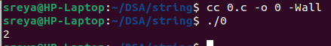

2.Write the strtok() function.
Ans:
#include <stdio.h>
#include <stdbool.h> /*to use bool */

bool check_delimiter(char c, const char *delim) { /*checks if the char is a delimiter or not*/
while (*delim) {
if (c == *delim) {
return 1; /*if char found in delim return true*/
}
delim++;
}
return 0;
}

char *strt(char *s, const char *delim) {
static char *next = NULL; /*uses static to remember the string until the end of program */
char *start;
if (s != NULL) {
next = s;
}
if (next == NULL) {
return NULL;
}
while (*next && check_delimiter(*next, delim)) { /*skips the initial delimiter if found*/
next++;
}
if (*next == '\0') {
next = NULL;
return NULL;
}
start = next;
while (*next && !check_delimiter(*next, delim)) { /*continues if delimeter not found and till string is not over*/
next++;
}
if (*next) {
*next = '\0';
next++;
}
else {
next = NULL;
}

return start; /*returns string*/
}

int main() {
char str[] = ",Hello, world; I am, Sreya."; /*Example string*/
char *ans; /*Stores the answer */
ans = strt(str, ",; ");
while (ans != NULL) {
printf("%s\n", ans);
ans = strt(NULL, ",; ");
}
return 0;
}
Output

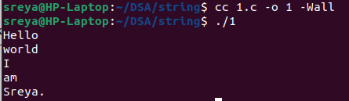

3.Write a function which finds the longest possible subsequence of one string into
another and returns the length + pointer to the subsequence.
Ans:
#include <stdio.h>
#include <string.h>

char * sub(char * s, char * t, int * ans){ /*ans is passed so it is updated in the function itself */
*ans = 0;
int c = 0;
int pos = -1;
int maxpos = -1;
int flag = 0;
for(int i = 0; i < strlen(s) ; i++){ /*Iterates through the entire string */
int d = i;
for(int j = 0; j< strlen(t); j++){
if(s[d]==t[j]){ /* Check if the current character matches */
if(flag == 0){
pos = d; /* Set the starting position of the match */
flag = 1;
}
d++;
c++;
}
else if(flag == 1){
flag = 0;
break;
}
}
if(c > *ans){
*ans = c; /* Update the length and start position of the longest substring */
maxpos = pos;
}
c = 0;
}
if(maxpos == -1){
return NULL; /*If not found returns NULL */
}
return &s[maxpos]; /* Return a pointer to the start of the longest matching substring */
}

int main(){
char s[] = "abcdemnopxyzmnot"; /*Example strings */
char t[] = "mnoptq";
int ans; /* Variable to store the length of the longest substring */
char * a = sub(s,t,&ans);
for(int i = 0; i < ans; i++){ /* Display the longest substring */
printf("%c",a[i]);
}
printf("\n");
return 0;
}
Output

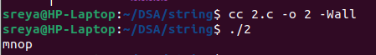

4. Write a function to find gcd() of 2 numbers.
Ans:
#include <stdio.h>
int gcd(int a, int b) {
if (a < 0) { /*can't caculate gcd of negative number */
return -1;
}
if (b < 0) {
return -1;
}
while (b != 0) { /* Apply the Euclidean algorithm to find the GCD */
int temp = b;
b = a % b;
a = temp;
}
return a; /* Return the GCD */
}

int main() {
int a = 10; /*Example numbers */
int b = 8;
printf("%d\n",gcd(a, b)); /* Print the GCD*/
return 0;
}
Output

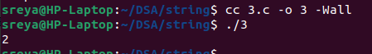

5.Write a function to find lcm() of 2 numbers.

Ans:
#include <stdio.h>

int gcd(int a, int b) { /*GCD function to help find LCM */
while (b != 0) {
int temp = b;
b = a % b;
a = temp;
}
return a;
}

int lcm(int a, int b){
if (a < 0) { /* If a or b is negative, return -1 to indicate an error */
return -1;
}
if (b < 0) {
return -1;
}
int ans = a * b;
ans = ans / gcd(a,b); /* Divide the product by the GCD to get the LCM */
return ans; /* Return the LCM */
}

int main() {
int a = 10;
int b = 8;
printf("%d\n",lcm(a, b)); /* Print the result */
return 0;
}

Output

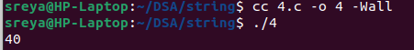

6. Write a function to convert a decimal number to a binary number and return the binary
representation in a string.

Ans:
#include <stdio.h>
#include <string.h>
#include <stdlib.h>

char * binary(int num){
if (num == 0) {
char *ans = (char *)malloc(2 * sizeof(char));
if (ans == NULL) {
return NULL; /* Check if memory allocation failed */
}
ans[0] = '0';
ans[1] = '\0';
return ans;
}
char arr[120]; /* Temporary array to hold binary digits in reverse order */
int i = 0;
while(num > 0){
arr[i++] = (num % 2) + '0';
num = num /2;
}
char * ans = (char *)(malloc(sizeof(char)*(i+1)));
if (ans == NULL) {
return NULL; /* Check if memory allocation failed */
}
for(int j = i - 1, k = 0; j >= 0; j--, k++){ /* Reverse the binary digits to get the correct order */
ans[k] = arr[j];
}
ans[i] ='\0'; /* Null terminator for the string */
return ans; /* Return the binary string */
}

int main(){
int a = 10;
printf("%s",binary(a)); /* Print the binary representation */
printf("\n");
return 0;
}
Output
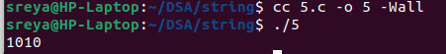

7. Write your own code for following library functions:
strcasecmp strsep strcasecmp strcoll
Ans:
#include <stdio.h>
#include <stdbool.h> /*to use bool */

bool check_delimiter(char c, char *delim) { /*helper function for strsep */
while (*delim) {
if (c == *delim) {
return 1;
}
delim++;
}
return 0;
}

int strcasecmp(char *s1, char *s2) {
while (*s1 && *s2) { /* Convert characters to lowercase */
char c1 = (*s1 >= 'A' && *s1 <= 'Z') ? *s1 + 32 : *s1;
char c2 = (*s2 >= 'A' && *s2 <= 'Z') ? *s2 + 32 : *s2;
if (c1 != c2) {
return c1 - c2; /* Return the difference if they are not equal */
}
s1++;
s2++;
}
return (*s1) - (*s2);
}

char *strsep(char **stringp, char *delim) {
char *start = *stringp;
if (start == NULL) {
return NULL;
}

char *end = start;
while (*end && !check_delimiter(*end, delim)) {
end++;
}

if (*end) { /* If a delimiter was found, replace it with a null character */
*end = '\0';
*stringp = end + 1;
}
else {
*stringp = NULL;
}

return start; /* Return the start of the answer */
}

int strcoll(char *s1, char *s2) {
while (*s1 && *s2) {
if (*s1 != *s2) {
return *s1 - *s2; /* Return the difference */
}
s1++;
s2++;
}
return (*s1) - (*s2);
}

int main() {
/*strcasecmp function */
char *s1 = "Sreya";
char *s2 = "sReya";
int res = strcasecmp(s1, s2);
if (res == 0) {
printf("The strings are equal.\n");
}
else if (res < 0) {
printf("The first string is less than the second string.\n");
}
else {
printf("The first string is greater than the second string .\n");
}
/*strsep function */
char str[] = "one,two,three";
char *delim = ",";
char *ans;
char *rest = str;
while ((ans = strsep(&rest, delim)) != NULL) {
printf("%s\n", ans);
}
/*strcoll function */
char *s3 = "Hello";
char *s4 = "World";
res = strcoll(s3, s4);
if (res == 0) {
printf("The strings are equal.\n");
}
else if (res < 0) {
printf("The first string is less than the second string.\n");
}
else {
printf("The first string is greater than the second string.\n");
}
return 0;
}

Output
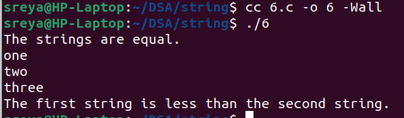

8. What are wide characters? Write a sample code using wcscmp function. (You have to
read wide character strings and then call wcscmp function)

Ans:
#include <stdio.h>
#include <wchar.h>
#include <locale.h> /*to use setlocale */

int main() {
setlocale(LC_CTYPE, ""); /* Set the locale to the user's default environment */
wchar_t str1[50]; /*intialise wide characters */
wchar_t str2[50];
fgetws(str1, 50, stdin); /* Read wide character strings */
fgetws(str2, 50, stdin);
size_t len1 = wcslen(str1); /* Get the length of wide character string */
if (len1 > 0 && str1[len1 - 1] == L'\n') {
str1[len1 - 1] = L'\0';
}
size_t len2 = wcslen(str2);
if (len2 > 0 && str2[len2 - 1] == L'\n') {
str2[len2 - 1] = L'\0';
}
int result = wcscmp(str1, str2); /* Compare the two wide character strings */
if (result == 0) {
wprintf(L"The strings are equal.\n");
}
else if (result < 0) {
wprintf(L"The first string is less than the second string.\n");
}
else {
wprintf(L"The first string is greater than the second string.\n");
}
return 0;
}

Output

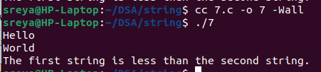

9. Write following functions: sine, sine-inverse, cosine, cosine-inverse. Then using sine and
cosine, write tan() function. Check whether calling sine(sine-inverse(x)) on your own
functions gives you x.

Ans:
#include <stdio.h>
#include <math.h>
#include <float.h> /* For NAN */

#define PI 3.14
#define MAX 1e-6f /* The number should be more than MIN */

/* Converts degrees to radians */
float deg_to_rad(float degrees) {
return degrees * PI / 180.0f;
}

/* Calculate sine of an angle (in radians) using Taylor series */
float sine(float x) {
float term = x; /* First term of Taylor series */
float sum = term;
float x_squared = x * x;
int i = 1;

while (fabs(term) > MAX) {
term *= -x_squared / ((2 * i) * (2 * i + 1));
sum += term;
i++;
}

return sum;
}

/* Calculate cosine of an angle (in radians) using Taylor series */
float cosine(float x) {
float term = 1.0f; /* First term of Taylor series */
float sum = term;
int i = 1;

while (fabs(term) > MAX) {
term *= -(x * x)/ ((2 * i - 1) * (2 * i));
sum += term;
i++;
}

return sum;
}

/* Calculate sine inverse */
float sine_inverse(float x) {
if (x < -1.0f || x > 1.0f) {
return NAN; /* Return NAN for out of range values */
}
float result = x;
float term = x;
int i = 1;

while (fabs(term) > MAX) {
term *= (2 * i - 1) * (x * x) / (2 * i);
result += term / (2 * i + 1);
i++;
}

return result;
}

/* Calculate cosine inverse */
float cosine_inverse(float x) {
return PI / 2 - sine_inverse(x);
}

/* Calculate tan of an angle (in radians) using sine and cosine */
float tangent(float x) {
return sine(x) / cosine(x);
}

int main() {
/* sine, cosine, tangent functions */
float angle_degree = 45.0f; /* Example angle in degrees */
float angle_radians = deg_to_rad(angle_degree);
printf("sine(%.2f degrees) = %.6f\n", angle_degree, sine(angle_radians));
printf("cosine(%.2f degrees) = %.6f\n", angle_degree, cosine(angle_radians));
printf("tangent(%.2f degrees) = %.6f\n", angle_degree, tangent(angle_radians));
/* The inverse functions */
float x = 0.5f; /* Example value within range of -1 to 1 */
printf("sin-1(%.2f) = %.6f\n", x, sine_inverse(x));
printf("sine(sin-1(%.2f)) = %.6f\n", x, sine(sine_inverse(x)));
return 0;
}

Output:
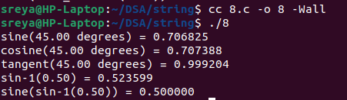

10.Write a program to reverse the digits of an integer and store the result as another
integer.

Ans:
#include <stdio.h>

int reverse_integer(int num) {
int reverse = 0;
while (num != 0) {
int digit = num % 10; /* Last digit of number */
reverse = reverse * 10 + digit;
num /= 10; /* Remove the last digit from the number */
}
return reverse;
}

int main() {
int number;
scanf("%d", &number);
int r_number = reverse_integer(number);
printf("%d\n", r_number);
return 0;
}

Output
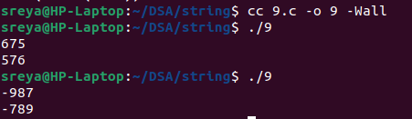

11. Write a program which reads a string and if the string has all digits in it, then
derives the integer it represents.

Ans:
#include <stdio.h>
#include <ctype.h>
#include <string.h>

/* Checks if a string contains only digits */
int digits(char *str) {
while (*str) {
if (!isdigit(*str)) { /* Check if the current character is a digit or not*/
return 0;
}
str++;
}
return 1;
}

int string_to_int(char *str) {
int ans = 0;
while (*str) {
ans = ans * 10 + (*str - '0'); /* Convert the current character to its integer value and update result */
str++;
}
return ans;
}

int main() {
char input[100];
scanf("%s", input);
if (digits(input)) {
int ans = string_to_int(input);
printf("%d\n", ans); /* Print the answer */
} else {
printf("The string does not contain only digits.\n");
}
return 0;
}

Output
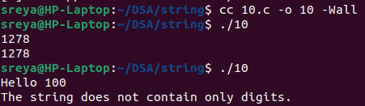

12. Write a function which does the following
void rev(char *str);
Reverses the string "str" in place (without using another string).

Ans:
#include <stdio.h>
#include <string.h>

void rev(char *str) {
if (str == NULL)
return;
for (int i = 0, j = strlen(str) - 1; i < j; i++, j--) {
char temp = str[i]; /* Swap characters at positions i and j */
str[i] = str[j];
str[j] = temp;
}
}

int main() {
char str[] = "Hello World";
printf("%s\n", str);
rev(str);
printf("%s\n", str);
return 0;
}

Output
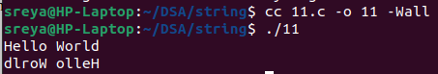
13. Write a function to find lcm of two numbers
Ans: #include <stdio.h>

int gcd(int a, int b) { /*GCD function to help find LCM */
while (b != 0) {
int temp = b;
b = a % b;
a = temp;
}
return a;
}

int lcm(int a, int b){
if (a < 0) { /* If a or b is negative, return -1 to indicate an error */
return -1;
}
if (b < 0) {
return -1;
}
int ans = a * b;
ans = ans / gcd(a,b); /* Divide the product by the GCD to get the LCM */
return ans; /* Return the LCM */
}

int main() {
int a = 10;
int b = 8;
printf("%d\n",lcm(a, b)); /* Print the result */
return 0;
}

Output

14.Write a function which cuts a string given by "str" on the character given in "ch"
and returns the first such word.
char *cutonchar(char *str, char ch);
For example: if 'str' is "something bad" and 'ch' is ' ' then it returns "something".
if 'str' is "something bad" and 'ch' is 'e' then it returns 'som'

Ans:
#include <stdio.h>
#include <stdlib.h>
#include <string.h>

char *cutonchar(char *str, char ch) {
char *pos = NULL;
for (char *p = str; *p != '\0'; p++) {
if (*p == ch) { /* Check if the current character matches */
pos = p;
break; /* Exit the loop if the character is found */
}
}
if (pos == NULL) {
char *ans = (char *)malloc(strlen(str) + 1); /* Allocate memory for a copy of the string */
if (ans == NULL) {
return NULL;
}
strcpy(ans, str);
return ans;
}
int len = pos - str;
char *ans = (char *)malloc(len + 1); /* Allocate memory for the new string */
if (ans == NULL) {
return NULL;
}
for (int i = 0; i < len; i++) {
ans[i] = str[i];
}
ans[len] = '\0';
return ans; /* Return the result string */
}

int main() {
char str[] = "something bad"; /*Example string */
char ch1 = ' ';
char ch2 = 'e';
char *result1 = cutonchar(str, ch1);
if (result1 != NULL) {
printf("%s\n", result1);
free(result1); /* Free the allocated memory */
}

char *result2 = cutonchar(str, ch2);
if (result2 != NULL) {
printf("%s\n", result2);
free(result2); /* Free the allocated memory */
}

return 0;
}

Output
